**Name**: Raj K Patel

**Roll No**: 20BCE218

**Course**: 2CSDE93 - Blockchain Technology

**Practical No**: 6

**Aim**: To build, implement and test voting mechanisms using Ethereum Blockchain. First, list the contestants on the screen and the vote they got. Whenever the user tries to vote for a particular contestant, the count of the votes for the particular contestant should increase by 1. Also, the user who has already voted should be marked. Marked means “the user has already voted once and will not be allowed to vote again”.

**Code:**

***// SPDX-License-Identifier: GPL-3.0***

pragma solidity >=0.7.0 <0.9.0; contract Ballot {

modifier onlyOwner() {

require(msg.sender == owner, "Only the owner can call this function.");

**_;**

**}**

***/* data structures */***

address owner; struct Voter {

bool voted; string votedTo; uint256 vote;

**}**

struct Proposal {

string name; uint256 voteCount;

**}**

**mapping(address => Voter) voters; *// for keeping track of who has already voted***

**Proposal[] public proposals; *// array of the candidates***

***/// Create a new ballot to choose one of***

***`proposalNames`.***

constructor(string[] memory proposalNames) { owner = msg.sender;

*for* (uint256 i = 0; i < proposalNames.length;

i++) {

proposals.push(Proposal({name:

proposalNames[i], voteCount: 0}));

**}**

**}**

function vote(uint256 proposal) external { Voter storage sender = voters[msg.sender];

require(!sender.voted, "You have already voted.

Can not vote again!!");

sender.voted = true; sender.vote = proposal;

sender.votedTo = proposals[proposal].name; proposals[proposal].voteCount += 1;

**}**

function winningProposal() public onlyOwner view

***returns* (uint256 elected_winner) {**

uint256 winningVoteCount = 0;

*for* (uint256 p = 0; p < proposals.length; p++) {

*if* (proposals[p].voteCount > winningVoteCount) {

winningVoteCount = proposals[p].voteCount;

elected_winner = p;

**}**

**}**

**}**

function winnerName() external onlyOwner view *returns*

(string memory winnerName_) {

uint256 winnerId = winningProposal(); winnerName_ = proposals[winnerId].name;

**}**

**}**

**Output:**

1. **Contact deployment**

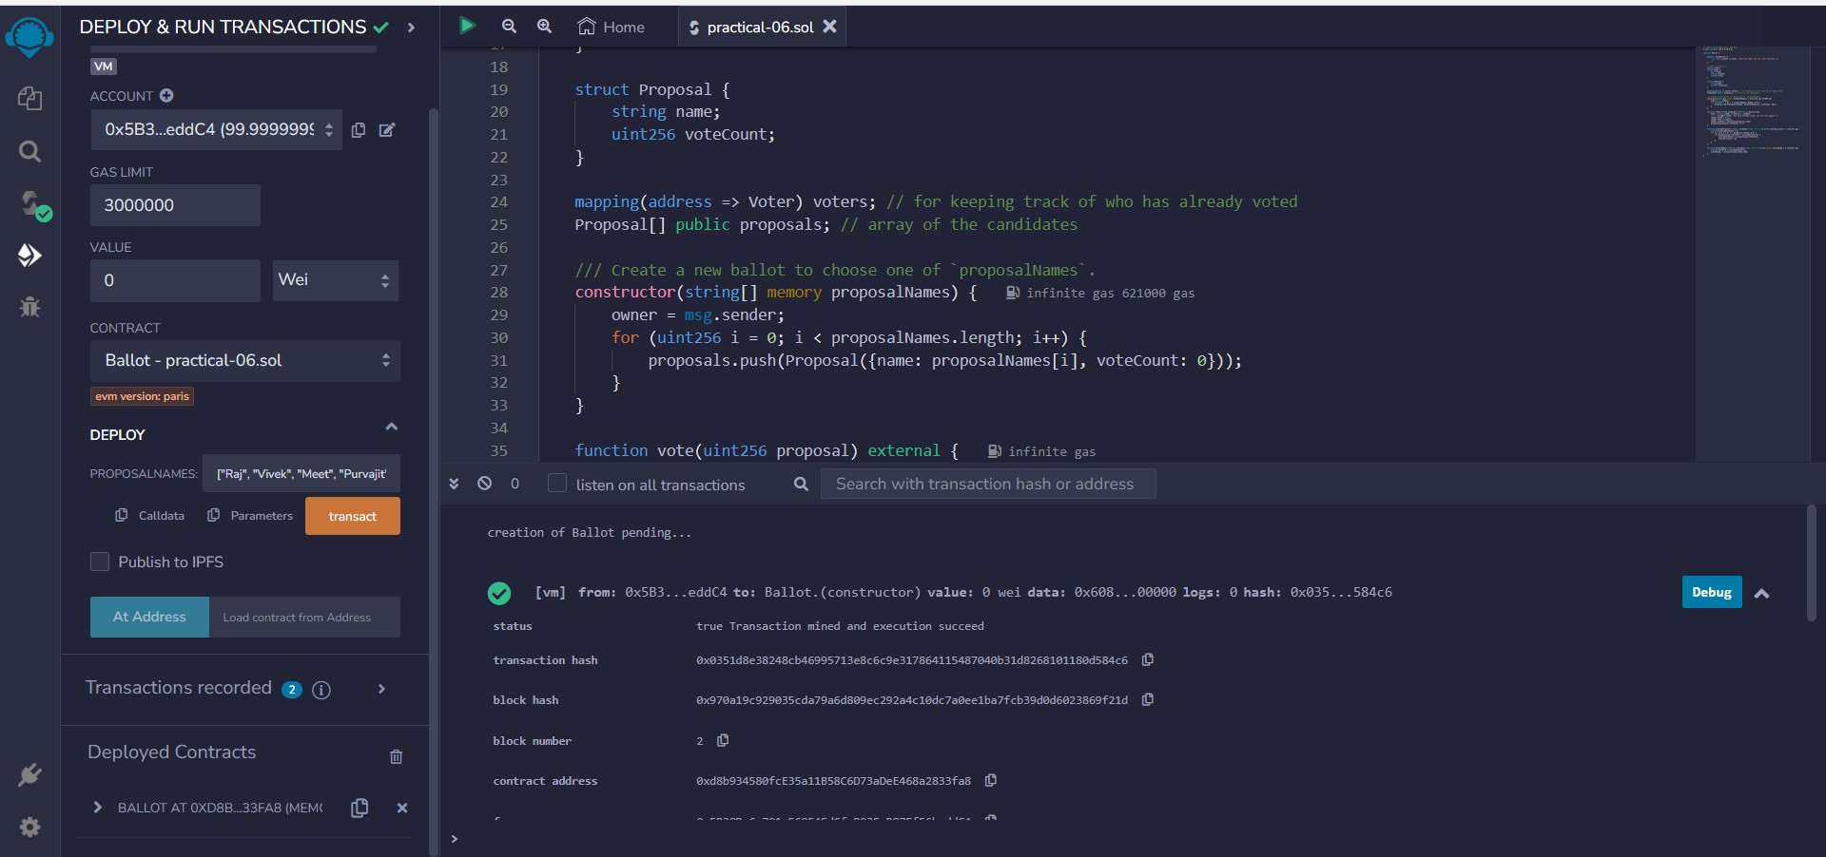

1. **Voting for a candidate**

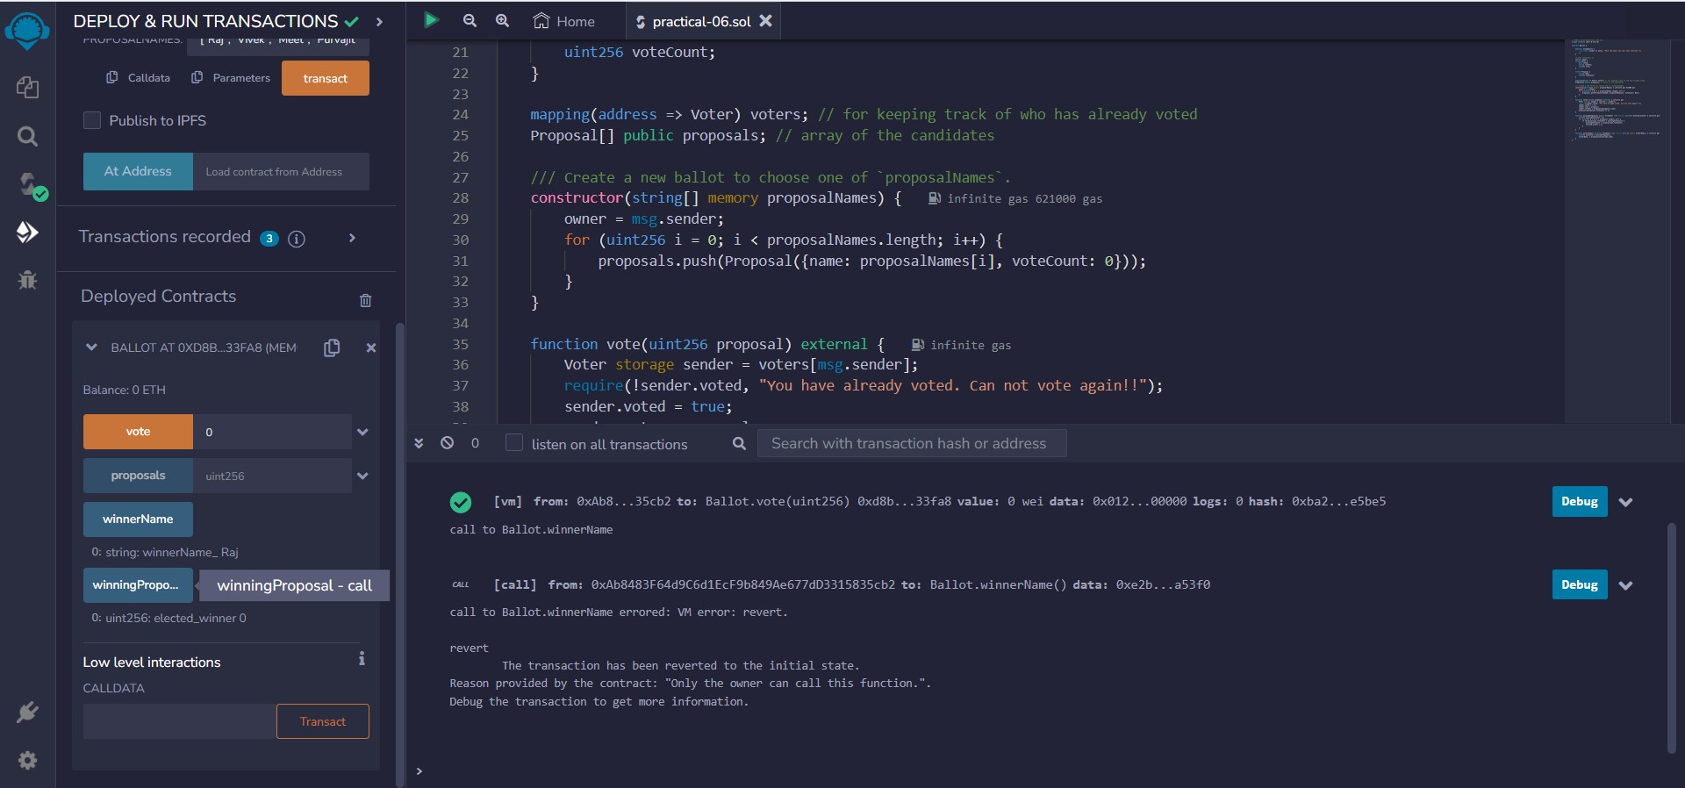

1. **Can not vote again**

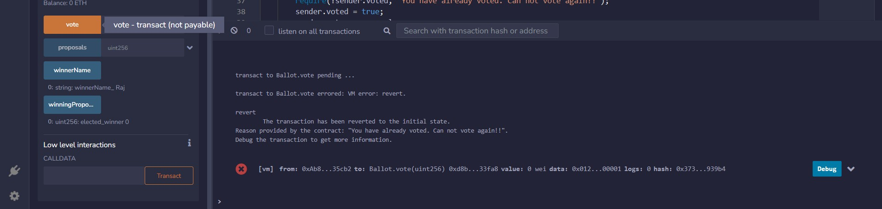

1. **Only owner can announce the results**

